Vision and Scope Document

for

**BUILDING AN ONLINE SHOE-SELLING WEBSITE**

**Version 1.0 approved**

**Prepared by Group 3 _ SE17A08**

**Process Impact**

**July 20, 2023**

**Table of Contents**

**1. Business Requirements** **4**

1.1. Background 4

1.2. Business Opportunity 4

1.3. Business Objectives 4

1.4. Success Metrics 4

1.5. Vision Statement 5

1.6. Business Risks 5

1.7. Business Assumptions and Dependencies 5

**2. Scope and Limitations** **6**

2.1. Major Features 6

2.2. Scope of Initial and Subsequent Releases 7

2.3. Limitations and Exclusions 7

**3. Business Context** **7**

3.1. Stakeholder Profiles 7

3.2. Project Priorities 8

3.3. Deployment Considerations 9

**Revision History**

| **Name** | **Date** | **Reason For Changes** | **Version** |
| --- | --- | --- | --- |
|  |  |  |  |
|  |  |  |  |

# Business Requirements

## Background

In today's digital age, online shopping has become increasingly popular, offering convenience and a wide range of choices. However, the shoe industry still faces challenges in transforming the traditional shoe-buying habits of customers. To address this, we propose the creation of an innovative online shoe store called "Hipster," aiming to revolutionize the way people shop for shoes.

## Business Opportunity

Hipster recognizes the need to change the perception of shoe shopping from a mundane task to an enjoyable experience. By leveraging advanced technology, a user-friendly interface, and a curated collection of trendy and unique footwear, Hipster aims to attract a new generation of customers who seek a seamless and personalized shopping experience.

## Business Objectives

BO-1: Decrease the amount of unsold inventory by 40% within 6 months of Hipster's launch, specifically targeting the month of July 2023.

Scale: Quantity of unsold shoes held in stock each week

Meter: Analysis of inventory management system records

Previous: 33% (2013, initial study)

Target: Less than 20%

Stretch: Less than 15%

BO-2: Minimize operational expenses for Hipster by 15% within 12 months following the initial release, focusing on cost reduction initiatives during July 2023.

BO-3: Increase average customer engagement time by 15 minutes per visitor per day within 6 months after Hipster's launch, with a particular emphasis on enhancing engagement during the month of July 2023.

## Success Metrics

SM-1: Ensure that 75% of customers who made at least 3 purchases per month on the Hipster website during Q3 2023 utilize the personalized recommendation feature at least once a week within 6 months following the initial release.

SM-2: Increase the average customer satisfaction rating on quarterly surveys by 0.5 on a scale of 1 to 6, compared to the Q3 2023 rating, within 3 months after the initial release, and by 1.0 within 12 months. This will be achieved through continuous improvement in product quality, customer service, and overall shopping experience..

## Vision Statement

Hipster envisions a future where online shoe shopping becomes an immersive and delightful experience that exceeds current industry standards. We strive to redefine the way people shop for footwear by integrating cutting-edge technology, offering carefully curated fashion collections, and providing exceptional customer service. Our goal is to create a seamless and enjoyable online shopping journey, where customers can discover and purchase their perfect pair of shoes with ease and satisfaction.

## Business Risks

RI-1: Potential dissatisfaction among shipping partners, resulting in delays and inconsistencies in the delivery process, impacting customer experience. (Probability = 0.6; Impact = 3)

RI-2: Inadequate engagement and collaboration with content creators, leading to a lack of compelling and engaging content for marketing and promotion. (Probability = 0.3; Impact

RI-3: Challenges in effectively managing and maintaining the admin page, leading to potential operational inefficiencies and difficulties in addressing customer inquiries and concerns. (Probability = 0.3; Impact = 3)

RI-4: Inconsistent communication and coordination with shipping partners may result in mismanaged deliveries, leading to customer dissatisfaction and negative feedback. (Probability = 0.5; Impact = 6)

RI-5: Difficulty in attracting and retaining talented content creators, affecting the quality and consistency of promotional materials and brand messaging. (Probability = 0.4; Impact = 7)

RI-6: Insufficient training and resources for admin page management, leading to errors in order processing, customer support, and data management. (Probability = 0.4; Impact = 5)

## Business Assumptions and Dependencies

AS-1: Systems with user-friendly interfaces will be available for Hipster's employees to efficiently process the expected volume of shoe orders on the website.

AS-2: Hipster will have a reliable team of staff and delivery vehicles to ensure all shoe orders are delivered within the specified delivery time slots, with a maximum delay of 15 minutes from the requested delivery time.

AS-3: The logistics and transportation infrastructure will support timely and efficient delivery of shoe orders to customers' locations.

DE-1: If shoe brands have their own online ordering systems, the Hipster Ordering System must be capable of seamless bidirectional communication with these systems to facilitate order management and fulfillment.

DE-2: Integration with reliable payment gateways and financial systems will be in place to ensure secure and smooth transactions on the Hipster website.

# Scope and Limitations

## Major Features

FE-1: Authentication of the system

FE-2: Place an order successfully

FE-3: Create, Read, Update, and Delete shop products

FE-4: Create, Read, Update, and Delete blog posts

FE-5: Complete a delivery for an order

FE-6: Manage income and order

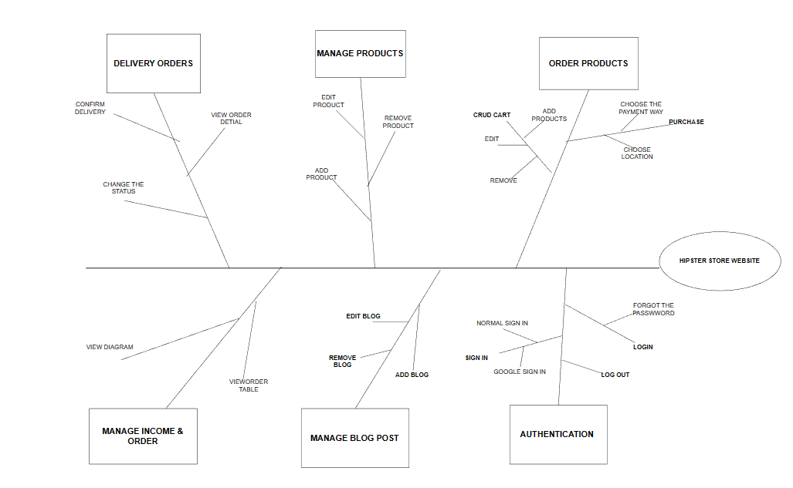

**Figure 1.** Partial feature tree for the Hipster sneaker shop

## Scope of Initial and Subsequent Releases

| **Feature** | **Release 1** | **Release 2** | **Release 3** |
| --- | --- | --- | --- |
| FE-1, Authentication | Google sign in | Fully implemented | Fully implemented |
| FE-2, Order Products | COD payment | Accept credit and debit card payments | Fully implemented |
| FE-3, Manage products | Create ,View, Remove, Update products | Fully implemented | Fully implemented |
| FE-4, Manage blog post | Not implemented | Create ,View, Remove, Update blog posts | Fully implemented |
| FE-5, Manage income & order | View Income | Fully implemented | Fully implemented |
| FE-6, Delivery order | Confirm the order | View detail and history order | Fully implemented |

## Limitations and Exclusions

LI-1: The website does not currently offer any discount program, which may limit the ability to attract price-sensitive customers or incentivize repeat purchase.

LI-2: Limited payment methods: At this time, the website may accept only certain payment methods (COD, VnPay), excluding some potential customers who prefer alternative payment options.

# Business Context

## Stakeholder Profiles

| **Stakeholder** | **Major Value** | **Attitudes** | **Major Interests** | **Constraints** |
| --- | --- | --- | --- | --- |
| Guest | Convenient and accessible browsing, relevant product offerings | Seek simplicity and ease of use, value efficiency in finding desired information | Exploring available shoe options, accessing basic product details, viewing pricing information. | Limited access to advanced features and personalized experiences, inability to make purchases or access customer support without becoming a registered customer |
| Customer | Quality products, personalized experience, excellent customer service | High quality expectations, user-friendly platform, prompt assistance and issue resolution | Variety of shoes, competitive pricing, detailed product information, accurate sizing guidance, reliable customer reviews, secure payment options, efficient order fulfillment, timely delivery | Budget limitations, time constraints, privacy and data security concerns |
| Content Creator | Product information, engaging and informative content | Creativity, attention to detail, understanding the target audience | Creating informative blogs showcasing product features, benefits, and usage. Crafting captivating narratives and visuals to attract and educate customers. | Time constraints, adhering to brand guidelines, collaborating with marketing and product teams |
| Shipper | Timely and reliable delivery, customer satisfaction | Punctuality, professionalism, attention to product handling | Ensuring efficient and secure product shipping, tracking packages to maintain transparency, coordinating with the shop and customers for smooth delivery | Time constraints in meeting delivery schedules, managing a high volume of shipments, adhering to safety and regulatory guidelines, dealing with unpredictable weather conditions or traffic delays |
| Seller | Sales revenue, customer satisfaction, brand reputation | Customer-oriented, proactive, goal-driven | Generating sales with quality products, competitive pricing, and promotions. Providing excellent customer service. Building a strong brand reputation | Inventory management, pricing profitability, handling returns, staying competitive in the market |
| Administration Store | Efficient store operations, streamlined processes, cost control | Organized, detail-oriented, focused on optimizing store performance | Ensuring accurate record-keeping, coordinating with suppliers for timely deliveries, maintaining a safe and clean store environment, overseeing staffing and scheduling, monitoring and analyzing sales data, implementing cost-saving measures | Budget limitations, time constraints, compliance with regulations and policies, adapting to changing market demands, addressing customer complaints or issues promptly |

## Project Priorities

| **Dimension** | **Constraint** | **Driver** | **Degree of Freedom** |
| --- | --- | --- | --- |
| **Features** | All features scheduled for release 1.0 must be fully operational | Achieving a functional and reliable product with all planned features implemented | Implement distinct roles for different user types: admin, seller, content creator, shipper, and customer. |
| **Quality** | 95% of user acceptance tests must pass; all security tests must pass | Ensuring high-quality software that meets user expectations and provides a secure experience | Scope for minor improvements or bug fixes after initial testing to achieve the quality targets |
| **Schedule** | Release 1 planned to be available by end of Q1 of next year, release 2 by end of Q2; overrun of up to 2 weeks acceptable without sponsor review | Meeting deadlines for product releases to maintain market | An overrun of up to 2 weeks for each release is acceptable without requiring sponsor review. |
| **Cost** | Manage the project budget efficiently | Keeping the project within budgetary limits and optimizing cost-effectiveness. | Manage the project budget efficiently, allowing for a reasonable budget overrun of up to 15% without requiring sponsor review. |
| **Staff** | 1 project manager (half-time) 1 business analyst (half-time) 3 developers 1 tester Additional resources available: 1 extra developer (if necessary) 1 half-time tester (if necessary) | Efficiently utilizing the available staff to deliver the project successfully. | Flexibility to use additional resources if necessary - 1 extra developer and 1 half-time tester. |

## Deployment Considerations

The web server software will need to be upgraded to the latest version. When deploying Hipster, it is crucial to consider various factors to ensure a successful launch. Thoroughly testing the website is essential to provide a seamless user experience, allowing customers to browse and shop effortlessly. Implementing effective marketing strategies will help generate awareness and attract a wide customer base. Establishing robust customer support channels will ensure that inquiries and concerns are addressed promptly, enhancing customer satisfaction.Collaborating with reliable logistics partners is vital to guarantee timely order fulfillment and delivery, providing a positive shopping experience..

To stand out from competitors, Hipster should focus on delivering an exceptional user experience. Optimizing the website's design, navigation, and performance will create a visually appealing and user-friendly platform. Offering a curated shoe collection that reflects the latest trends and caters to diverse customer preferences will attract fashion-conscious individuals.

Personalized recommendations based on customer preferences will enhance the shopping experience, helping customers find their perfect pair of shoes effortlessly. Additionally, implementing strategic discounts and promotions will incentivize customers and encourage repeat purchases, fostering customer loyalty.

By considering these factors and striving for excellence in every aspect of the business, Hipster aims to redefine the online shoe shopping experience, providing convenience, style, and value to its customers.